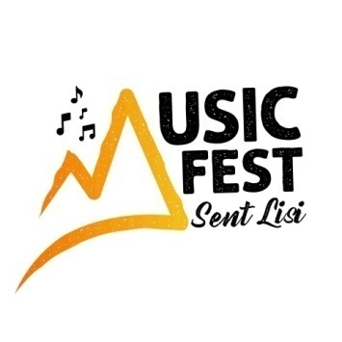

**ARTISTE REGISTRATION FORM**

**OVER $20,000 IN CASH PRIZES UP FOR GRAB!!**

**YOUTH STAR CONTEST**

**COMPETITION OPEN TO ARTISTES 29 YEARS AND UNDER**

**Philip Marcellin Grounds, Vieux Fort**

**Saturday December 20, 2025 - 3:00 to 10:00 P.M.**

**PLEASE COMPLETE THE FOLLOWING and e-mail to the address below**:

**PERFORMING ARTISTE STAGE NAME:**

**NAME OF PRODUCER (Songwriter/Producer):**

**SINGLE**

Full Name:

Date of Birth:

ID No:

**GROUP** (number in group) Two/Three (Maximum of three)

Full Name:

Date of Birth:

ID No:

Full Name:

Date of Birth:

ID No:

A copy of your ID must accompany the completed Audition Registration Form

Full Name:

Date of Birth:

ID No:

**CIRCLE OR UNDERLINE ONE OF THE FOLLOWING GENRES;**

**GOSPEL, DENNERY SEGMENT, DANCEHALL/REGGAE, KAISO, SOCA, HIPHOP, R&B, AND EMERGING GENRES**

**AUDITION TRACKS:**

Prepare an audio recording of your intended audition track and send it to us; with this completed form: [**musicfestsentlisi@gmail.com**](mailto:musicfestsentlisi@gmail.com) and/or WHATSAPP: **(758-723-9015).**

**Each artiste is required to record one set of three minutes maximum.**

A panel of Judges will review the auditions tracks and select artistes to compete at the November 2025 semi-finals.

The **CLOSING DATE** for submission of tracks and audition forms: **October 31, 2025.**

**MANAGER/CONTACT PERSON:**

Full Name:

Email:

Tel No: